Rolling correlation: USDCAD and EURGBP
Method 05 / daily log returns / windows 20, 60, 100 / Low-value

Study setup
Logical pair: USDCAD , EURGBP
Broker symbols: USDCAD_i , EURGBP_i
Tier: Low-value (low_value)
Snapshot: 2026-11-03_majors_alpari_D1
Timeframe: D1
Matched return window: 1999-01-06 to 2026-11-02 (UTC bar dates)
Matched return count (rows before rolling): 7185
Dropped unfinished last bar dated 2026-11-03 UTC after a tick-volume check against the prior complete day.
Rolling windows W: 20, 60, 100 trading days
Live-shaped n for each score: n = W (not the full history length)
Complete matched rows (CSV): USDCAD-EURGBP_Rolling_D1.csv
Complete matched rows (HTML): USDCAD-EURGBP_Rolling_D1_data.html

Method carried forward
Rolling Pearson r is computed on matched daily log returns of close, ln(close_t / close_t-1), in the broker quote direction. Quotes are not inverted. For each day t with a full window, r_W uses the last W matched return pairs ending at t. That live-shaped sample size is W (20, 60, or 100), not the full multi-year history. The first W-1 days have no score. r is symmetric under swap of the two symbols. A high |r| in one window does not prove cause, lead-lag, or a trading signal. Short windows are noisier; long windows are slower to reflect a break.
How to read a live day: after both daily candles close, the newest r_20 uses the last 20 matched log returns, r_60 the last 60, and r_100 the last 100. Compare those three to each other and to the full-sample baseline below. A break is when the short window moves far from the baseline or flips sign while the baseline was meaningful.

Full-sample Pearson baseline (method 01 v001)
Copied full-sample Pearson r for USDCAD-EURGBP: -0.014622. This is a historical average link, not the live state.

Rolling results
W | latest_r | mean | median | min | max | std | pct_|r|>=0.4 | pct_|r|>=0.7 | n_roll
20 | 0.031654 | -0.02688 | -0.041532 | -0.770405 | 0.813242 | 0.287676 | 17.74 | 0.75 | 7166
60 | -0.105504 | -0.022787 | -0.030149 | -0.569773 | 0.571388 | 0.214386 | 7.62 | 0 | 7126
100 | 0.007327 | -0.02253 | -0.039634 | -0.509253 | 0.49608 | 0.195219 | 5.35 | 0 | 7086
n_roll is the number of days that had a complete window. pct_|r|>=0.4 and pct_|r|>=0.7 are the share of those days where the absolute rolling correlation cleared the threshold.

Conclusion
For USDCAD and EURGBP, full-sample Pearson baseline r=-0.0146. Latest rolling scores: r_20=0.0317, r_60=-0.1055, r_100=0.0073. Stability: moderate window-to-window variation. Agreement with baseline: r_20=0.032 opposite sign vs baseline; r_60=-0.106 near baseline; r_100=0.007 opposite sign vs baseline. Tier line: low interest — still near zero in recent windows. This is a monitoring summary, not a trade signal.

What to look at in this file next time
1) Latest r_20 vs r_60 vs r_100 in the results table. 2) Whether short-window latest has the same sign as the baseline. 3) The rolling chart for stretches where |r| collapsed. 4) The CSV if you need a different chart later.

Charts
Rolling Pearson r (20 / 60 / 100)
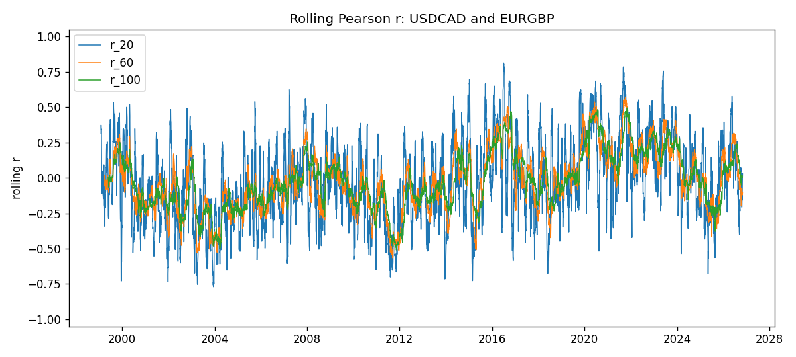
Daily closes

Daily log returns
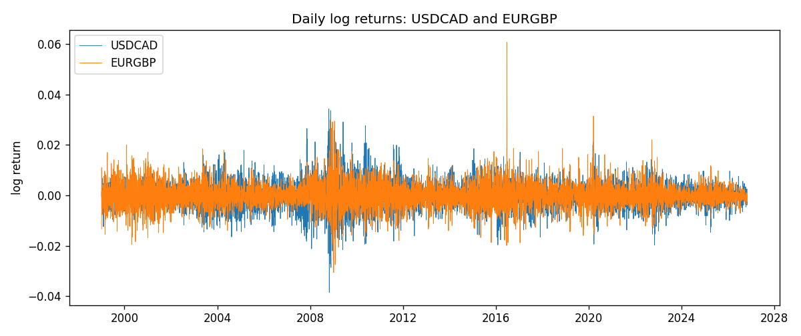

Data report
Every matched row with r_20, r_60, and r_100 is in the sibling CSV and HTML. This Word section holds column summaries and the first and last 15 rows of the rolling table.
Columns: time, USDCAD_close, EURGBP_close, USDCAD_tick_volume, EURGBP_tick_volume, USDCAD_log_return, EURGBP_log_return, r_20, r_60, r_100
Column summaries
column | count | mean | std | min | 25% | 50% | 75% | max
USDCAD_close | 7185 | 1.26668 | 0.168851 | 0.916 | 1.118 | 1.29833 | 1.3723 | 1.6137
EURGBP_close | 7185 | 0.786976 | 0.0966689 | 0.5735 | 0.6878 | 0.83391 | 0.86533 | 0.977
USDCAD_tick_volume | 7185 | 81049.4 | 147325 | 37 | 5563 | 40946 | 71633 | 1.41082e+06
EURGBP_tick_volume | 7185 | 87109.9 | 145486 | 154 | 6553 | 44326 | 81375 | 1.42468e+06
USDCAD_log_return | 7185 | -8.08e-06 | 0.00514591 | -0.0385975 | -0.00283484 | 5.597e-05 | 0.00272835 | 0.0343632
EURGBP_log_return | 7185 | 1.874e-05 | 0.00486681 | -0.0306737 | -0.00262366 | -0.00010035 | 0.00255918 | 0.0607539
r_20 | 7166 | -0.0268801 | 0.287676 | -0.770405 | -0.229249 | -0.0415316 | 0.180331 | 0.813242
r_60 | 7126 | -0.0227867 | 0.214386 | -0.569773 | -0.172614 | -0.0301488 | 0.118819 | 0.571388
r_100 | 7086 | -0.0225301 | 0.195219 | -0.509253 | -0.16768 | -0.0396343 | 0.112986 | 0.49608
First 15 matched rows
time | USDCAD_close | EURGBP_close | USDCAD_log_return | EURGBP_log_return | r_20 | r_60 | r_100
1999-01-06 | 1.5118 | 0.7019 | -0.000330677 | -0.0133033
1999-01-07 | 1.5141 | 0.7097 | 0.00152021 | 0.0110514
1999-01-08 | 1.511 | 0.7062 | -0.00204952 | -0.00494386
1999-01-11 | 1.5057 | 0.7053 | -0.00351378 | -0.00127524
1999-01-12 | 1.5157 | 0.7077 | 0.00661947 | 0.00339703
1999-01-13 | 1.5226 | 0.708 | 0.00454202 | 0.000423819
1999-01-14 | 1.5332 | 0.7066 | 0.00693765 | -0.00197936
1999-01-15 | 1.5245 | 0.7012 | -0.00569057 | -0.00767158
1999-01-18 | 1.526 | 0.7017 | 0.000983445 | 0.000712809
1999-01-19 | 1.5302 | 0.7007 | 0.00274851 | -0.00142613
1999-01-20 | 1.5211 | 0.7021 | -0.00596469 | 0.00199601
1999-01-21 | 1.5146 | 0.7016 | -0.00428238 | -0.000712403
1999-01-22 | 1.5184 | 0.7004 | 0.00250577 | -0.00171184
1999-01-25 | 1.5197 | 0.6966 | 0.000855798 | -0.00544024
1999-01-26 | 1.52 | 0.6962 | 0.000197388 | -0.000574383
Last 15 matched rows
time | USDCAD_close | EURGBP_close | USDCAD_log_return | EURGBP_log_return | r_20 | r_60 | r_100
2026-10-13 | 1.4214 | 0.84458 | -0.00463957 | 0.000201304 | -0.0649804 | -0.19829 | -0.0499196
2026-10-14 | 1.42356 | 0.84553 | 0.00151848 | 0.00112419 | -0.101379 | -0.182192 | -0.0504472
2026-10-15 | 1.41843 | 0.84479 | -0.00361015 | -0.000875574 | -0.0620442 | -0.167845 | -0.0361269
2026-10-16 | 1.41357 | 0.84307 | -0.00343221 | -0.00203808 | -0.010935 | -0.135854 | -0.0210578
2026-10-19 | 1.41091 | 0.84259 | -0.00188353 | -0.00056951 | -0.064584 | -0.160093 | -0.00680043
2026-10-20 | 1.40569 | 0.83957 | -0.0037066 | -0.00359063 | 0.0356532 | -0.0966936 | 0.0211108
2026-10-21 | 1.4045 | 0.83839 | -0.000846918 | -0.00140647 | -0.0981229 | -0.0732564 | 0.0115244
2026-10-22 | 1.40081 | 0.83682 | -0.00263073 | -0.00187439 | -0.206714 | -0.0776393 | 0.0194825
2026-10-23 | 1.40085 | 0.83751 | 2.85545e-05 | 0.00082421 | -0.181194 | -0.0767447 | 0.0240009
2026-10-26 | 1.40093 | 0.83762 | 5.71066e-05 | 0.000131333 | -0.116015 | -0.102475 | 0.0221585
2026-10-27 | 1.40449 | 0.83595 | 0.00253795 | -0.00199573 | -0.157322 | -0.121412 | 0.0117396
2026-10-28 | 1.39911 | 0.83651 | -0.00383793 | 0.000669672 | -0.114679 | -0.119558 | 0.00387585
2026-10-29 | 1.39895 | 0.83553 | -0.000114365 | -0.00117222 | -0.114466 | -0.118793 | 0.00228296
2026-10-30 | 1.39751 | 0.83351 | -0.00102987 | -0.00242055 | -0.0301859 | -0.105463 | 0.00643518
2026-11-02 | 1.39837 | 0.83426 | 0.000615191 | 0.000899405 | 0.0316544 | -0.105504 | 0.00732724

